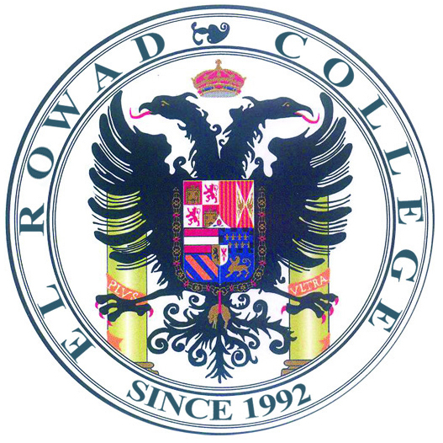
El Rowad Language School
Secondary Stage
Time Table
1 Sec. - 2 Sec. - 3 Sec.
Session | Time
 | From | TO
Line | 7:40 | 8:00
1st Session | 8:00 | 8:40
2nd Session | 8:40 | 9:10
3rd Session | 9:10 | 9:40
4th Session | 9:40 | 10:10
5th Session | 10:10 | 10:40
6th Session | 10:40 | 11:10
7th Session | 11:10 | 11:40
Break | 11:40 | 12:20
8th Session | 12:20 | 12:55
9th Session | 12:55 | 1:30

