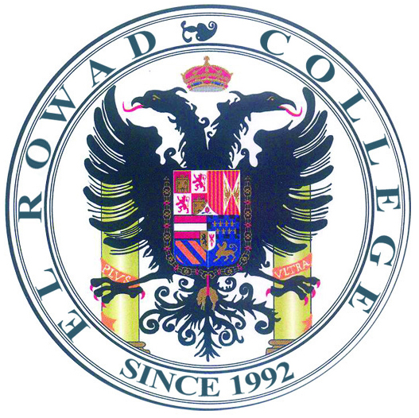

K.G Department
Dear Parents,
We hope that you are having a safe and relaxing holiday. The KG department is starting a TWO weeks program for its kid beginning of Sunday 20th of September 2020. The program will be seen on the face book page “Hi, Mrs. Hoda says hello". We expect parents to fully support the school by encouraging their kids to watch the lessons and finish all the sheets successfully.
We wish you and our kids a successful school year.

School Administration

