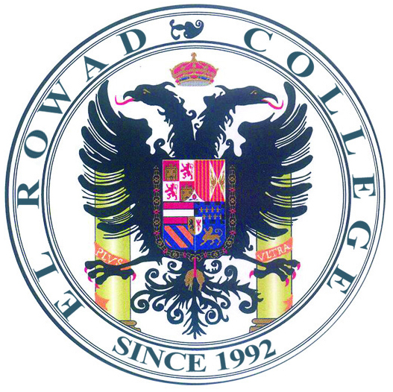
محافظة القاهرة
إدارة شرق مدينة نصر التعليمية
مدارس الرواد للغات
المرحلة الإعدادية

Memo (2)
2020/2021
Dear Parents,
We wish you a good health, safe life and a wonderful vacation. As we are keen on our student's educational level. We have decided to start online sessions on (zoom program) covering the syllabus of the duration from 15/3/2020 till the end of the last term.

The schedule will be uploaded soon on the students Gmail account.

You are kindly asked to support your children so that our students will benefit.

Here are some ways to support our student.
1) Make sure that you sent the mails of your kids; otherwise they will miss the opportunity to join the online session.
(Note: It's a must to create gmail account)
2) All students should attend the sessions on time and don't miss any session.
They should log in 5 mins, before the session to be able to accept the invitation.
3) Students must sit in a quiet place wearing suitable & appropriate outfit.
4) Misbehaving students during the sessions will be denied access and not allowed to log in again.
5) Students are asked to interact with their teachers and do the homework daily.
Notice that there will be a graded quiz at the end of the sessions.

* For further details and important notice, the school will be contacting you via
phone calls and SMS.

We wish our students all the best.

